ARYABHATT NATIONAL MATHS COMPETITION 2020
https://www.facebook.com/2238852776332500/posts/2714837922067314/?sfnsn=scwshmo

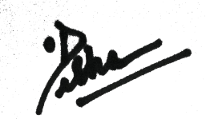

PRINCIPAL

