Dear Students, you may be aware that the two gas giant planets – Jupiter and Saturn are inching close to each other in the night sky. On 21st December 2020 they will be very close to each other and appear almost as a single body.
Those who have telescopes can observe these planets with their features (Jupiter with its moons and Saturn with a ring) but for the students who don’t have a telescope, please don’t get dismayed as they can see them with naked eye. Also, astronomy enthusiasts can go hands-on with this conjunction, using simple hand-made equipment.

Link for registration Is :
https://tinyurl.com/CrossStaffMakingworkshopNSCM.
Last Date of Registration: 14 December 2020
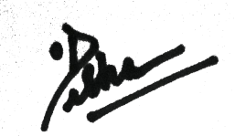

PRINCIPAL

