GNS sports activity for the year 2021-2022 Please find the Link

https://forms.gle/yqWvMB2hS9tRtRkh8

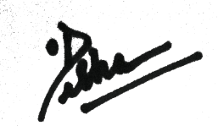

PRINCIPAL

