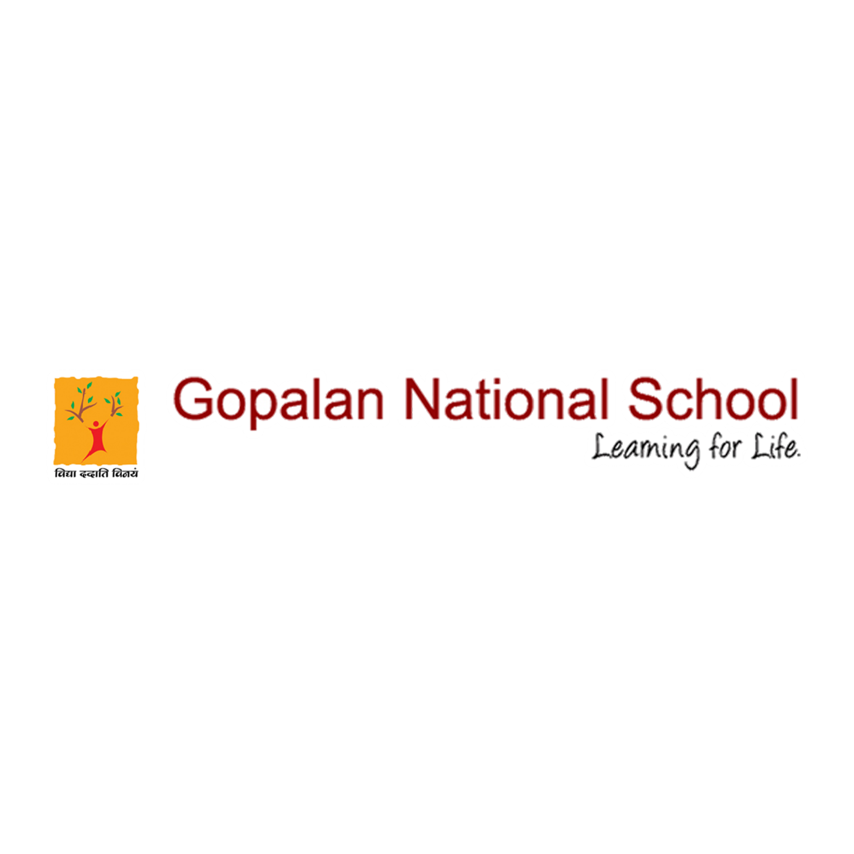

ALUMNI MEET 2020
It is a matter of great pride and honour for GNS when its students spread their wings and take flight into the infinite sky.
Any institutions’ alumni are key to its growth, the Alumni Meet, “Reunion 2020” of GNS, was held on 23rd Dec 2010. The occasion was graced by more than 200 Alumni across various batches from various parts of the country.
Speaking on the occasion, the Principal Mrs Dibha Samal underlined and praised the achievements of Alumni of GNS in all walks/spheres of life.
The Alumni Meet 2020 closed at a very emotional note. However, everyone appreciated the efforts of the school in organizing the Meet during the pandemic season. Everyone departed with the resolve to visit again in June 2021 and spread the message amongst all who could not attend this time.

Please click the below link to view the event
https://www.facebook.com/gopalannationalschool/videos/459480495443536/

