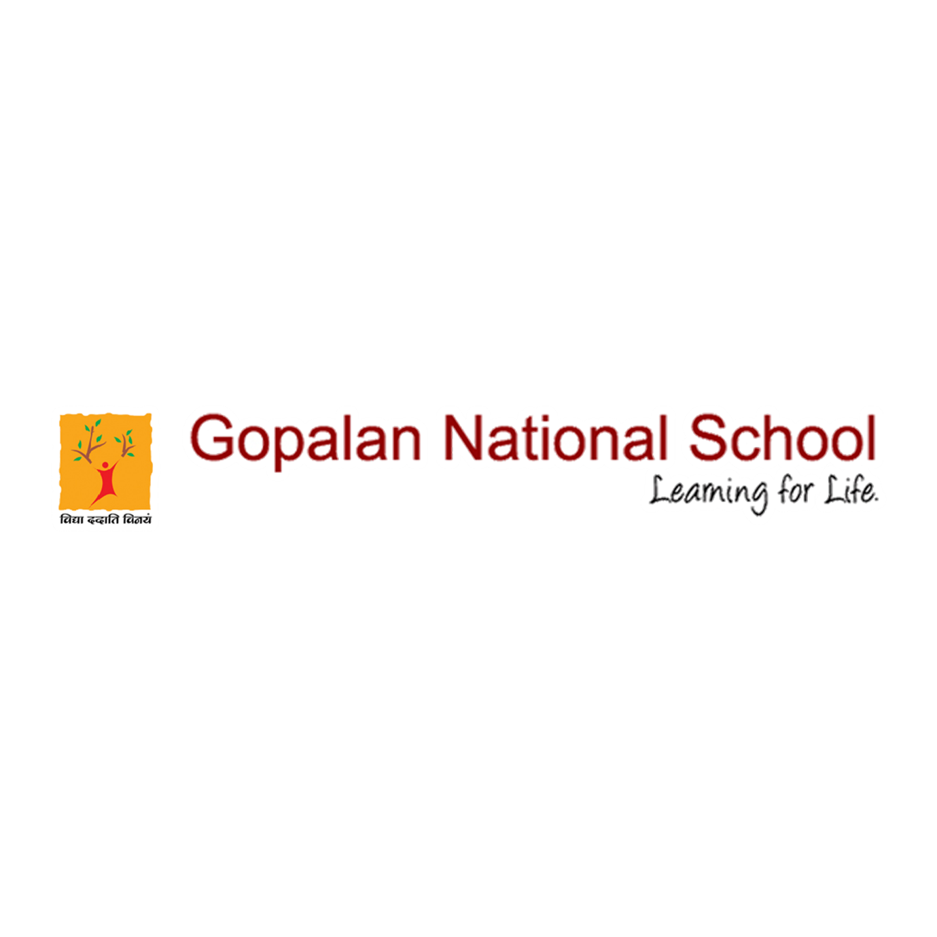

Christmas Celebration

GNS wish you all a Blessed Christmas and may the New Year (2021) bring much Hope, Peace, Happiness and Good Health to all.
Christmas fills the air with joy. Students of Pre-primary had a virtual
Christmas Assembly, where lots of activities and surprises were organised.
The class teachers made Christmas Cards for the children which was compiled in a form of a video. The day ended with the National Anthem.

Please click the below link to view the event
https://www.facebook.com/gopalannationalschool/videos/690206151696953/
https://www.facebook.com/gopalannationalschool/videos/1387052291641743/
https://www.facebook.com/gopalannationalschool/videos/231061168400751/
https://www.facebook.com/gopalannationalschool/videos/393468198581615/
https://www.facebook.com/gopalannationalschool/videos/2918109938411047/
https://www.facebook.com/gopalannationalschool/photos/pcb.3684364648276194/3684362118276447/?type=3&theater

