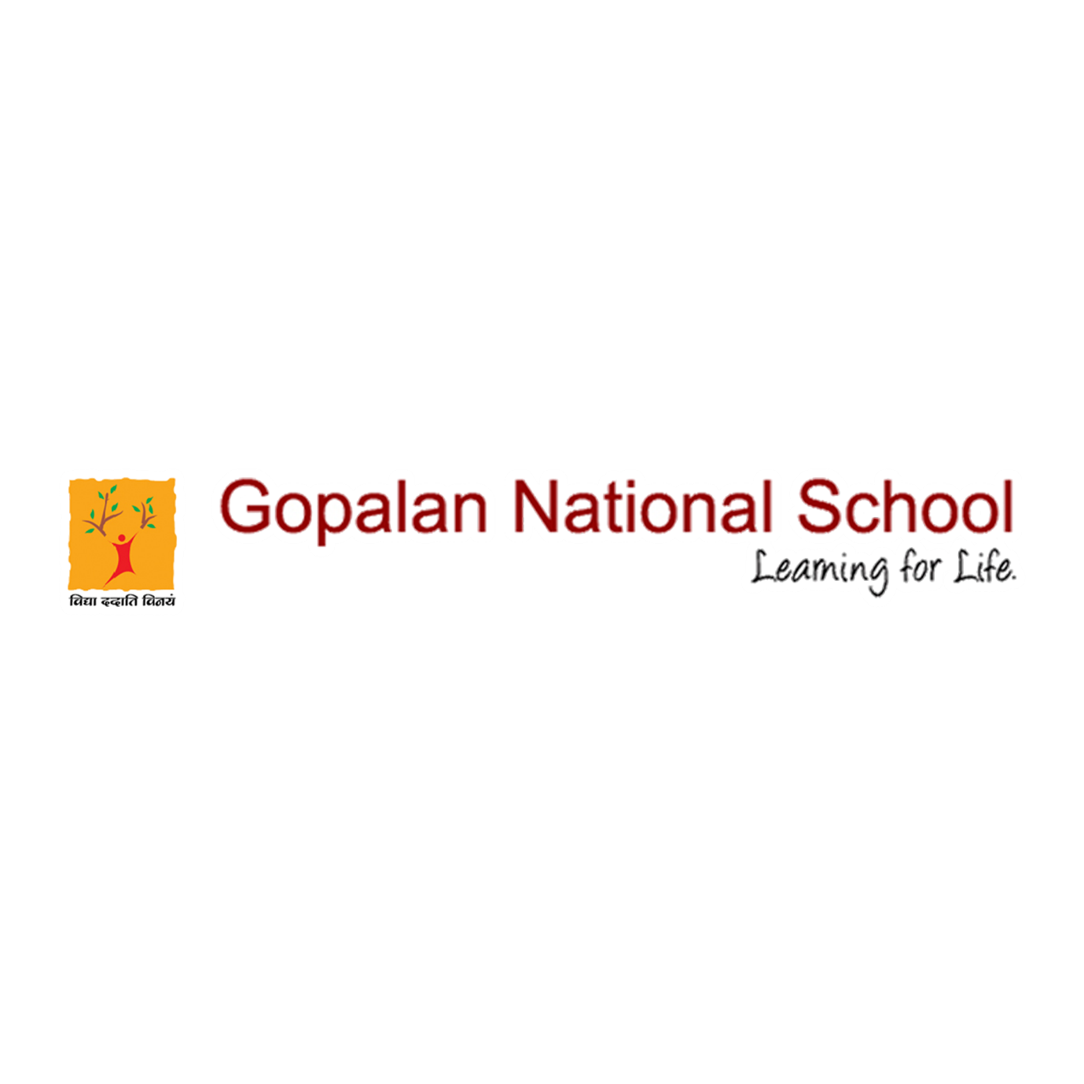

SANITATION IN GOPALAN NATIONAL SCHOOL

S U R E L Y B U T S L O W LY,
C A U T I O U S L Y B U T B R A V E L Y,

With an alert mind and responsible attitude we have to initiate the process of coming back to the school premises. It gives us great pleasure to share with you that after careful deliberation, intensive planning and organizing.
We are ready to welcome small groups of students back to school, to carry out urgent curriculum related work.
This is a decision which has been taken after a thorough evaluation of our ability to follow Government mandated safety protocols and in fact our own standards which places the safety of students and staff above everything else.
At this point, we would like to appreciate the hard work of the Team Admin for their efforts to create safe spaces, and protocols to ensure safety of all, and leaving no stone unturned to make sure our children can walk back into school with confidence.

Please click the below link to view the event
https://www.facebook.com/gopalannationalschool/videos/1059497331218424/

