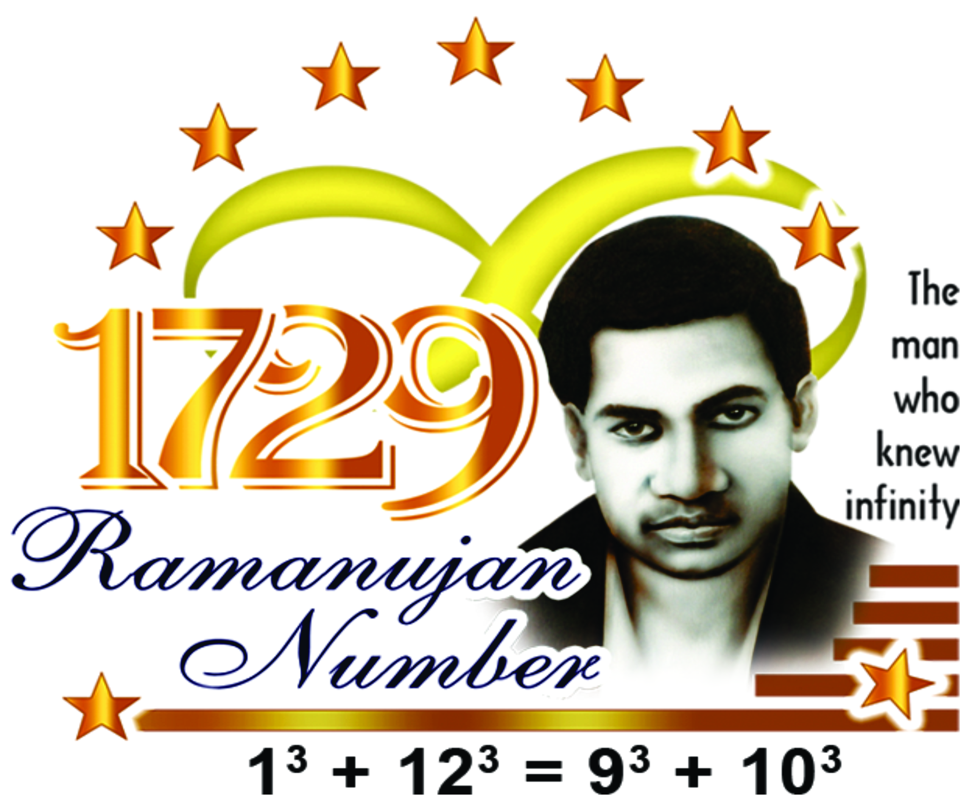

09-07-2020.

Dear Teachers,

Greetings from Ramanujan Museum & Math Education Centre
We are pleased to announce a Webinar on ‘How to remove Math Phobia’.
This FREE webinar is exclusively for Primary math teachers to understand how re- grouping is taught in lower classes.

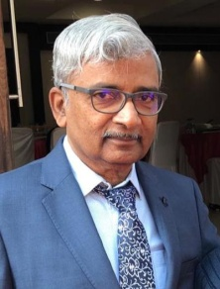
The resource person is Mr.A.T.B.Bose, the Co- Founder & Secretary of Ramanujan Museum & Math Education Centre, Chennai. He is an educationist and has developed more than 50 math learning manipulative and has also written math lab work books for classes 1 - 10. He has also authored ‘Math Edge' published by Oxford University Press, Primary level course books for students of classes 1 -5. He has conducted more than 200 workshops throughout India for math teachers. Kindly pre-register a max of 5 math teachers in the attached format. Your Principal is also welcome to join the webinar.

Topic: Remove Math Phobia
For: Primary Level Math Teachers
Date: 20th July 2020 – Addition with regrouping
Date: 22nd July 2020 – Subtraction with regrouping
Time: 2.00 pm to 4.30 pm.
Contact: +91 94449 09264
Register: ramanujan125@gmail.com

With warm regards,
Ms.G.Varani
(Admin. Manager)

Registration form  “REMOVE MATH PHOBIA” |  |  | Date:20th & 22nd Mon & Wed July, 2020.  Time: 2.00 pm to 4:30 pm
School: | GOPALAN NATIONAL SCHOOL |  | ICSE
Email: | gns@gopalanschool.com | Pin code: | 560048
Principal: | MRS. DIBHA SAMAL | Cell: | 9845697368
Email: | gnsprincipal@gopalanschool.com | WhatsApp No: | 9845697368
Participant’s Details
Participant 1: | MRS. SUSHMITA REJITH | Class: | V std
Email: | susmitharejith@gmail.com | WhatsApp No: | 9483277824
Participant 2: | MRS. KOUSALYA RAJESH | Class: | IV STD
Email: | Kousalya.rajesh@gmail.com | WhatsApp No: | 9717653602
Participant 3: | MRS. VIDYA SUNDARESAN | Class: | III STD
Email: | vidya.sundaresan@gmail.com | WhatsApp No: | 9449689234
Participant 4: | MRS. SHRUTI NIGAM | Class: | II STD
Email: | sudhiren@yahoo.co.uk | WhatsApp No: | 9916349580
Participant 5: | MRS. TULIKA R UPADHAYA | Class: | I STD
Email: | tulika2018pranavam@gmail.com | WhatsApp No: | 9582942259
Note:The link will be sent to the participants directly to their email id. WhatsApp number is required to form groups in which teachers can post their difficulties in entering the webinar or they can ask any questions. The group will be deleted once the Webinar is over.

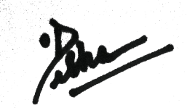

PRINCIPAL

