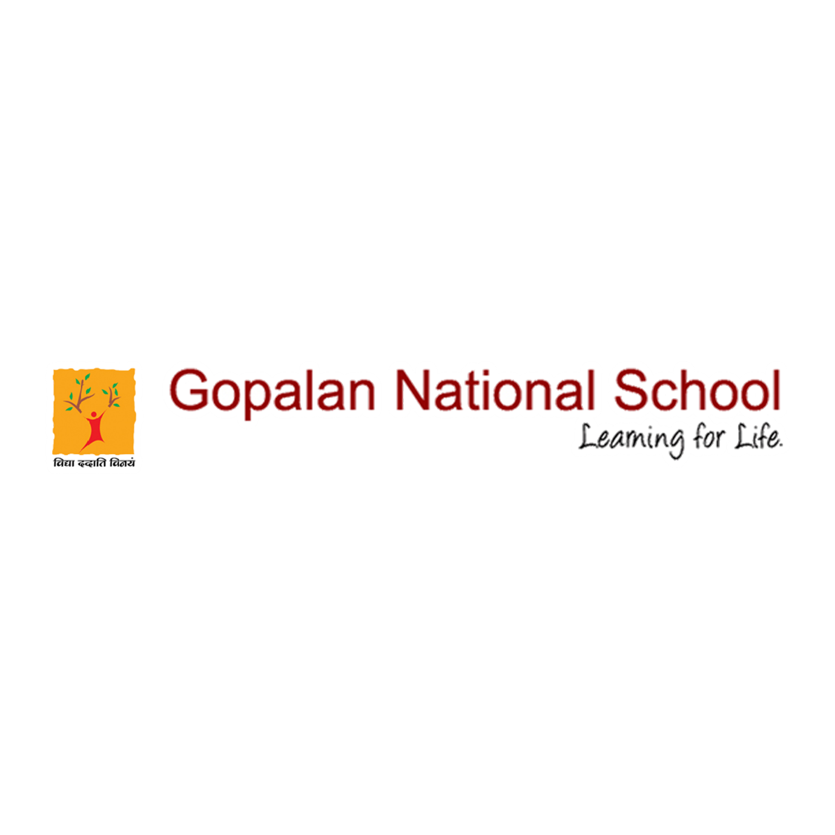

Newsletter # November 2020

Please click the below link to view the event
https://www.facebook.com/gopalannationalschool/videos/4892129307523874/
https://www.facebook.com/gopalannationalschool/videos/381820016454136/
https://www.facebook.com/gopalannationalschool/videos/223338079250778/
https://www.facebook.com/gopalannationalschool/videos/411280259987721/
https://www.facebook.com/gopalannationalschool/videos/128617065761702/
https://www.facebook.com/gopalannationalschool/videos/397481004652235/

