ICSE Registration Form

A Gentle reminder to all the parents that tomorrow is the last date to submit your ward’s ICSE registration. School code and subject code are mentioned below for your reference.

School Code | KA217
S.No | Not to fill
SCD | Not to fill
Subject Codes
Group I  English  Hindi Kannada  History Civics& Geography | 01  05  06  50
Group II  Mathematics  Science Environmental Science | 51  52  82
Group III  Computer Applications Economic Applications  Art Physical Education | 86  87  60  72

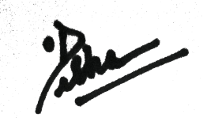

PRINCIPAL

