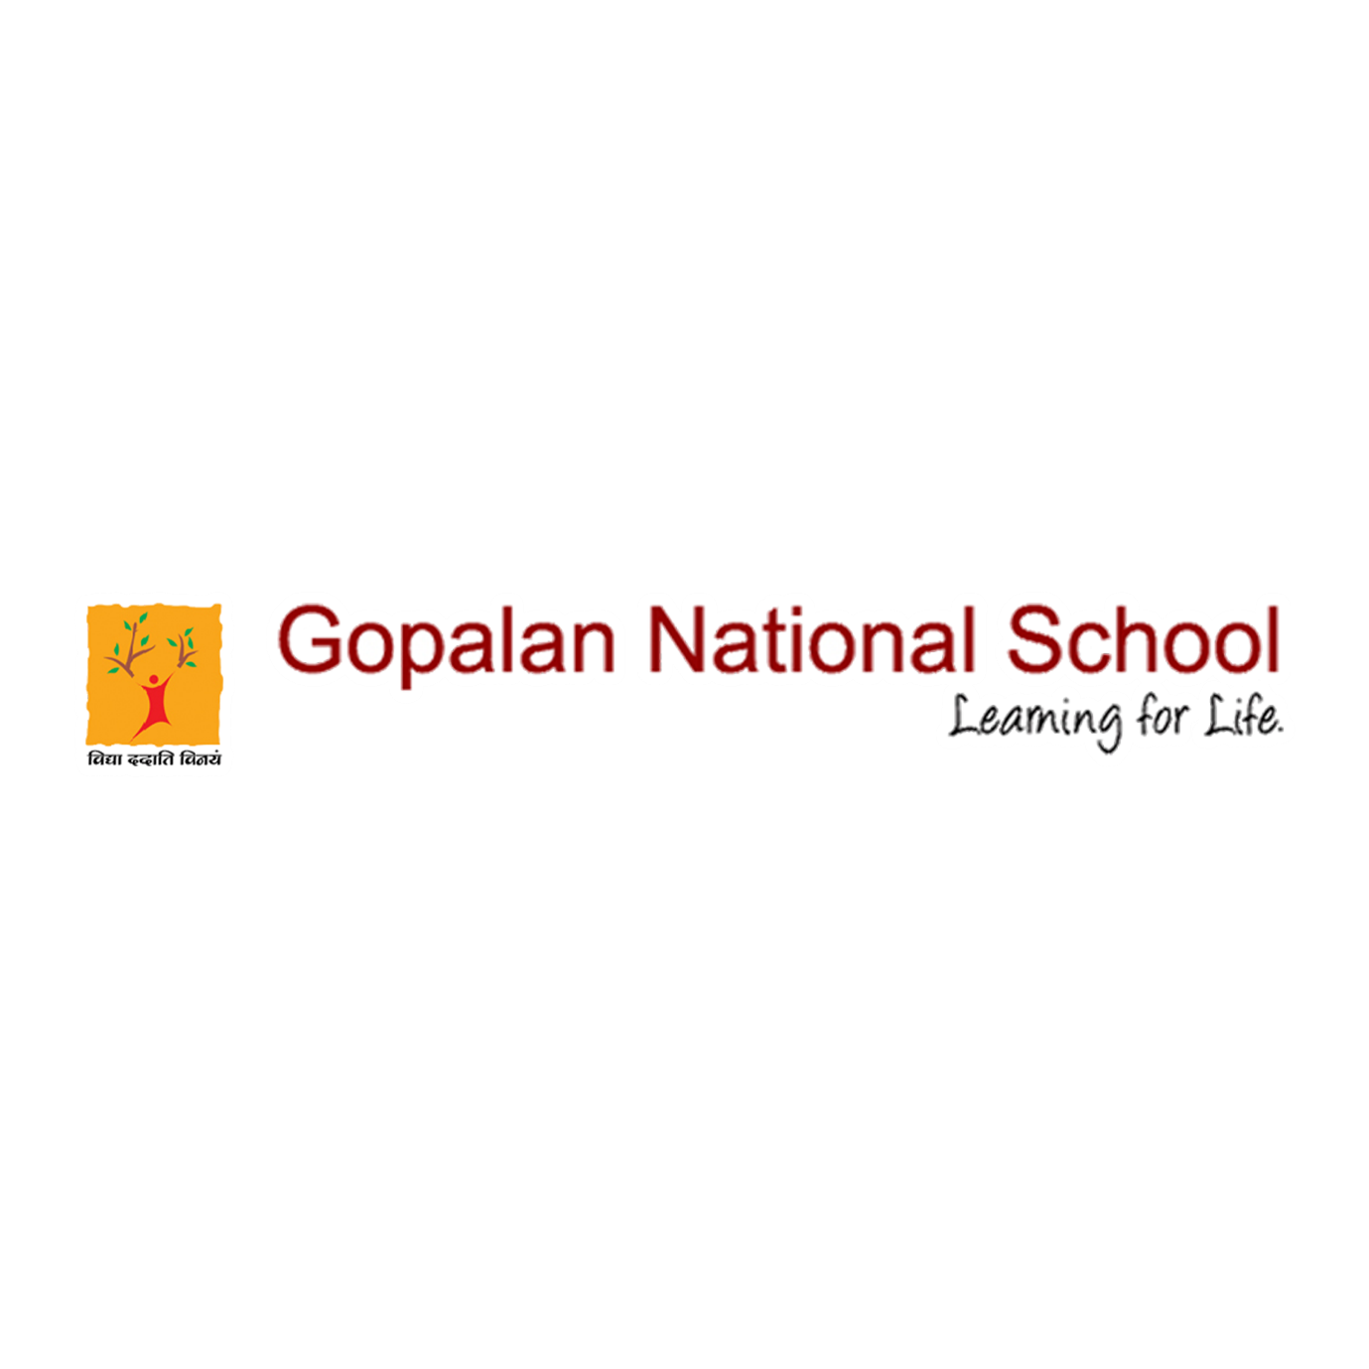

Vijay Diwas Celebration

Vijay Diwas Celebration by the Kannada Department.
Vijay Diwas is observed every year on December 16 as a mark of victory over Pakistan in the 1971 war that also led to the creation of Bangladesh.

Please click the below link to view the event
https://www.facebook.com/gopalannationalschool/videos/698184291135781/

https://www.facebook.com/gopalannationalschool/photos/pcb.3646383628740963/3646382825407710/?type=3&theater

https://www.facebook.com/gopalannationalschool/videos/127657889068797/

