

D/P, Please note w.e.f Monday (11-01-2021), X standard students will be following the schedule mentioned below.

X A - Monday and Thursday
X B - Tuesday and Friday
X C - Wednesday and Saturday
Timings - 8.30am to 11.10am

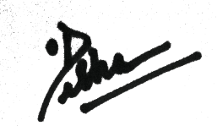

PRINCIPAL

