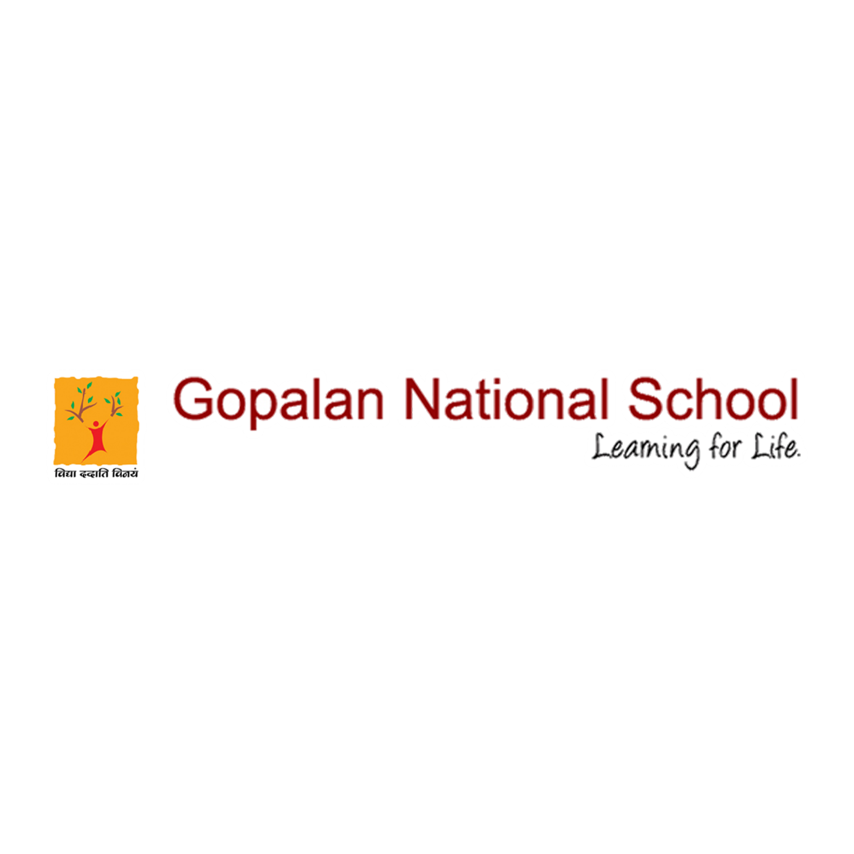

COMMUNITY SERVICE

It is an integral part of our education system. Through service to others, students improve their self-esteem, develop a sense of responsibility, and develop sensitivity to the needs of others and the community as a whole.

Please click the below link to view the event
https://www.facebook.com/gopalannationalschool/videos/313510673218377/

