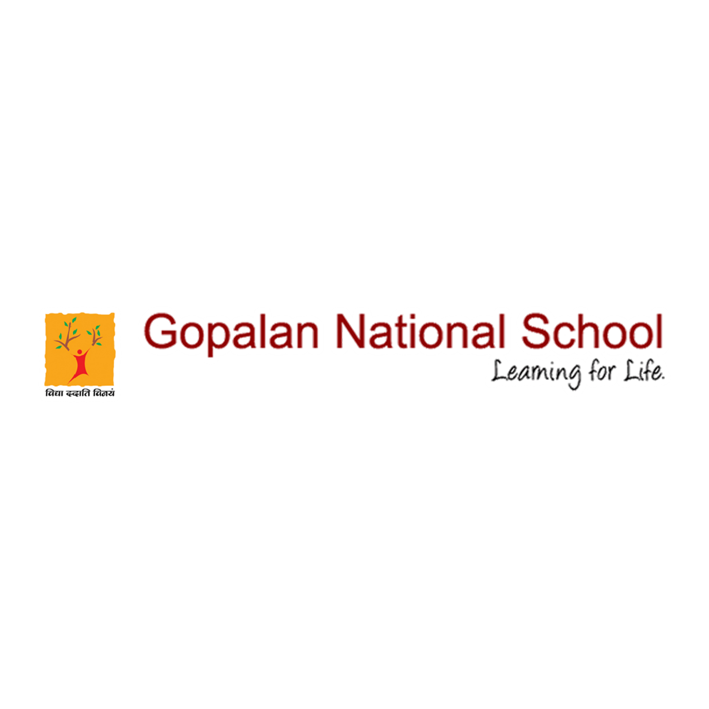

GNS FIT INDIA ACTIVITIES

Please click the below link to view the event
https://www.facebook.com/gopalannationalschool/videos/1109838712791713/

