

D/P, The school will remain closed on Thursday ,14 January 2021 on account of “Makar Sankranti”. However the office will be open from 10 AM to 2PM for Admission.
We wish you and your family a Happy Makar Sankranti.

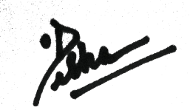

PRINCIPAL

