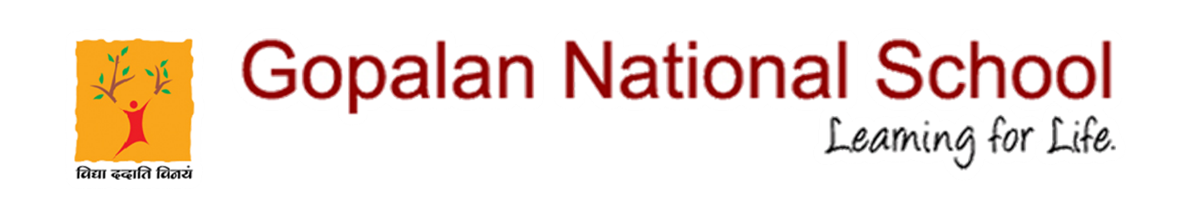

Greetings and a warm welcome to the New Academic Year!
To familiarize the parents about the new classes, system and the teachers, a Virtual Orientation program has been scheduled on 22.05.2021at 10AM.

Please click on the following link to join the meeting: https://teams.microsoft.com/l/meetup-join/19%3ameeting_NzFhMDEwODctYzE2OC00N2Q0LWI4ZWUtMWMwMmM1YjU4N2E3%40thread.v2/0?context=%7b%22Tid%22%3a%22fc14e468-6561-46fb-b9e4-77fbbc536c62%22%2c%22Oid%22%3a%22c013e113-4e76-4e91-b348-ba4796285b37%22%2c%22IsBroadcastMeeting%22%3atrue%7d&btype=a&role=a

