

PFA the CAIE/IGCSE Orientation Program Invite and Link below to join for your reference.

Link to join IGCSE Parent Orientation @ 10:00 AM: 9-Jan-2021, Saturday https://teams.microsoft.com/l/team/19%3ac38954635ad04ef1a6c83abe3fae94b4%40thread.tacv2/conversations?groupId=b41fafe8-d39d-40f7-bc38-432d1dfd86ad&tenantId=2caf384b-718d-401b-a955-2838147cf76e

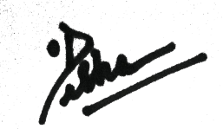

PRINCIPAL

