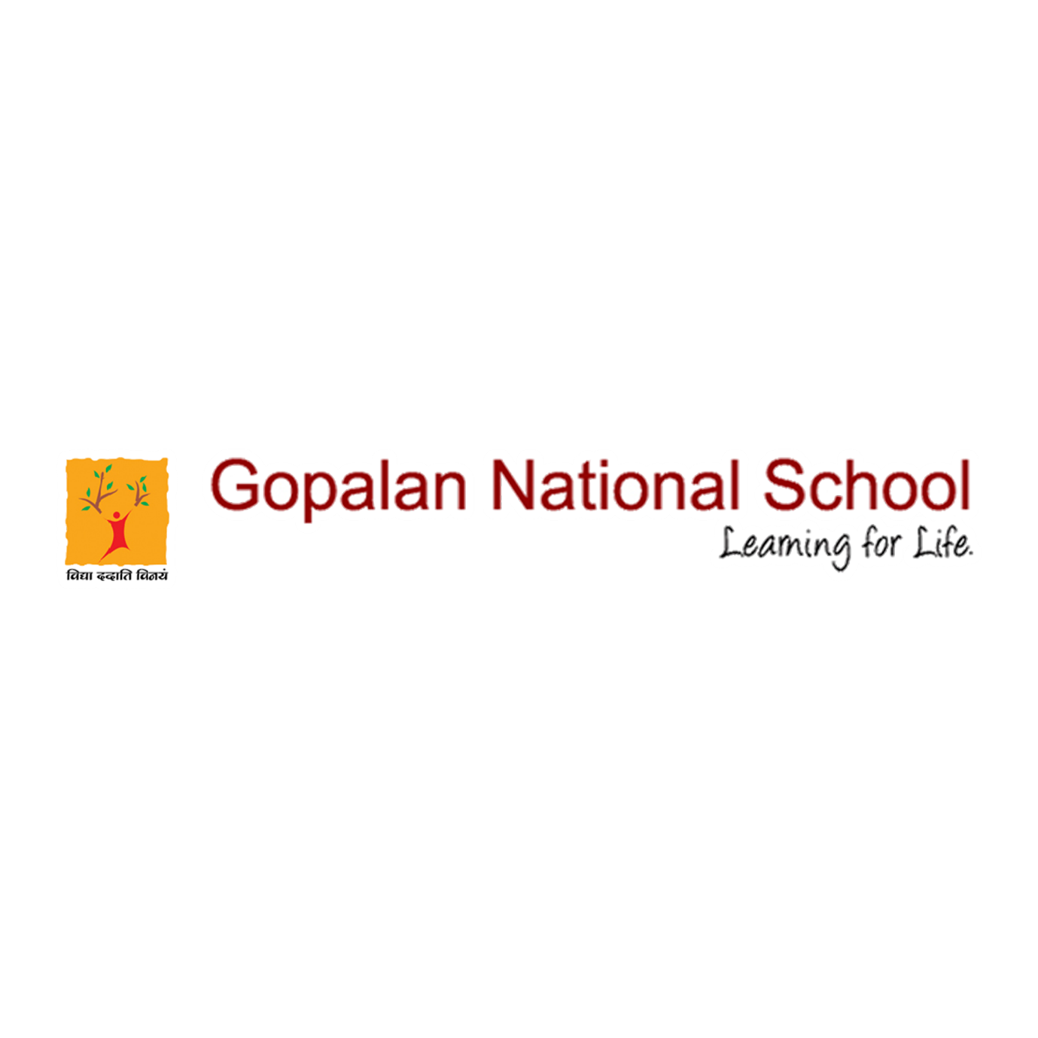

Staff Sports Activity

It's a well-known phenomenon that physical activity makes you feel good - boosting your self-esteem, helping you concentrate, look and feel better.
And GNS has always been thriving to keep this motto high with all its staff.
Here's few things which motivates our support staff and teachers in giving their best.

Please click the below link to view the event
https://www.facebook.com/gopalannationalschool/videos/1048429738977137/

