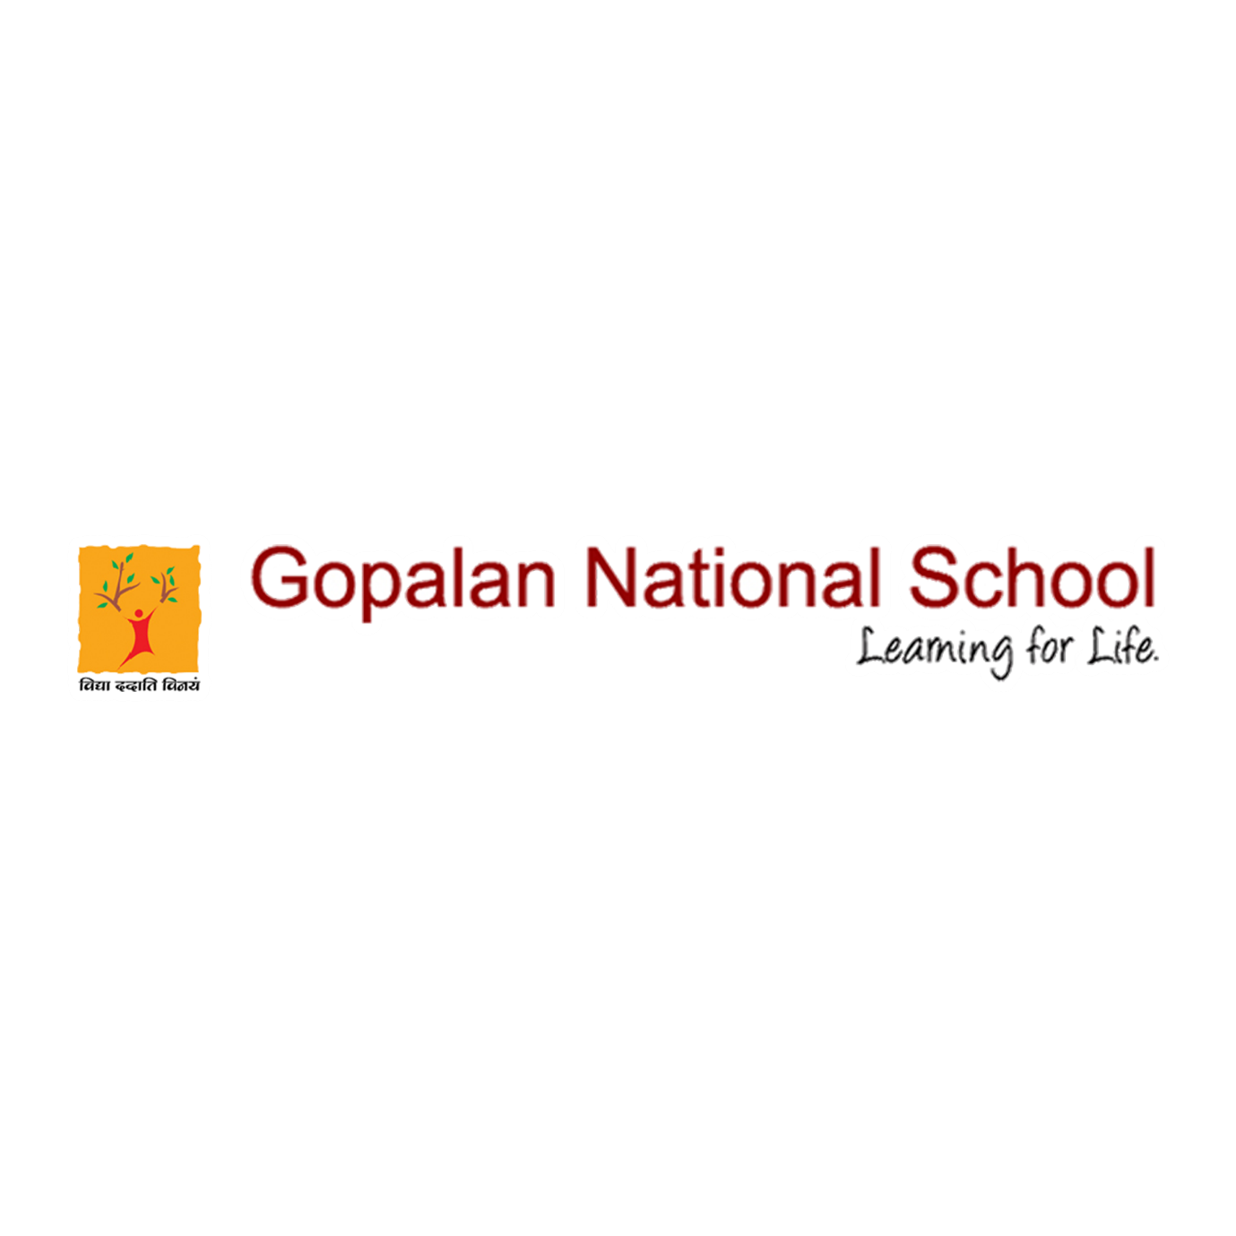

TTC-Winter-Cricket-Championship-U14

Congratulations Arhaan and Team GNS and special compliments for beating KIOC💐💐💐
Arhaan - Man of the match 32 Runs from 22 balls and 4 wickets
TTC-Winter-Cricket-Championship-U14/Gopalan-National-School-(-GNS-)-vs-KIOC-U14-B

Please click the below link to view the event
https://www.facebook.com/gopalannationalschool/photos/a.1873354399377237/3679648262081166/?type=3&theater

https://www.facebook.com/gopalannationalschool/photos/a.1873354399377237/3687301057982553/?type=3&theater

