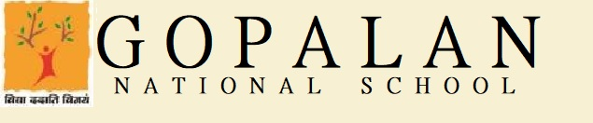
VIII STANDARD SYLLABUS FOR UNIT TEST – 1 (JULY 2021)
ENGLISH LANGUAGE | Chapter 1 – Nouns Chapter 2 - Determiners, (Composition and Personal letter will be included)
ENGLISH LITERATURE | Chapter 1 (The Boy who broke the bank & The lost Dances of Crane) Chapter - 2 ( The Narayanpur Incident)
2ND LANGUAGE HINDI | LITERATURE; CH-2 नौकर CH-3 शेर और तोमचा  LANGUAGE; CH-3(तत्सम- तद्भव ) CH-4 वाक्य CH-5 संज्ञा CH-20 शब्द तथा वाक्य संबंधी अशुद्धियाँ ( P.N.167),  CH-21विलोम शब्द ( P.N.173)सत्य से अग्रज CH-22 पर्यायवाची शब्द ( P.N.177)1-20 CH-23-अनेक शब्दों के लिए एक शब्द( P.N.182)1-20  Formal Letter
3RD LANGUAGE KANNADA | CHAPTER 1 - BIRBALLANA JANME POEM 1 - ANNADHATHA
MATHS | Exponents, Squares and square roots, Cubes and cube roots, Compound Interest
CHEMISTRY | CH 1 - MATTER CH 4 - ATOMIC STRUCTURE
BIOLOGY | CH 1 - TRANSPORT IN PLANTS CH 2 - REPRODUCTION IN PLANTS
PHYSICS | Chapter1 Matter, Chapter2 physical quantities
HISTORY & CIVICS | History--CH--1--Towards the Modern Period Civics--Ch--1--The Indian Legislature
GEOGRAPHY | Ch-2.Population Ch-3.Migration. Map of India- Mountains, Plateau,Plains, Islands, Rivers
COMPUTERS | Ch-1-Operating Systems and Graphical User Interface-Roles and Functions Ch-2-Spreadsheets-Formulas and Functions
3RD LANGUAGE KANNADA | Ch 1 - Namma desha bharata, Ch 2 Sanyasi bekku. Numbers 1-100.
3RD LANGUAGE HINDI | Ch-1 हुआ सवेरा,  Ch-2 खेल दिवस
3RD LANGUAGE SANSKRIT | पाठ २ लङ् लकार(प्रथम पुरुष); पाठ ३ लङ् लकार (मध्यम पुरुष)
3RD LANGUAGE FRENCH | Ch 1 - Les monuments et les musee parisiens Ch 2 -Les vrai amis(upto pg.16)

